# 02. Catering

Create a web page (HTML5 + CSS3) that looks and behaves like the provided screenshot

You are given all of the required resources.

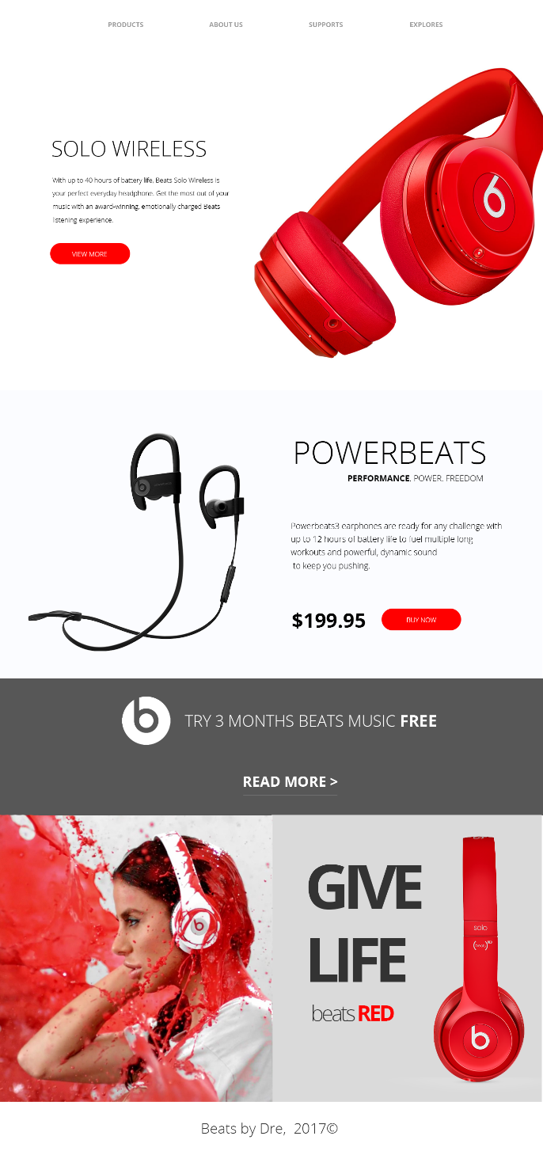

## Output

The output should be valid **HTML5** + **CSS3** + **images** that implement the above responsive site.

## Constraints

* Use the Google Font - "Open Sans"
* The site should open correctly in the latest version of Chrome
* Pixel-perfect implementation is NOT required
* You are NOT permitted to use libraries like Bootstrap